Report for Lab Session 1

Student: Yan Fei

Tutor: Dr. David Siddle

February 17, 2008

I declare that this assignment is my own work, that sources of reference are acknowledged and that it has not been submitted for any other course. I understand that plagiarism is a serious offence under the University’s regulations and that appropriate penalties will be applied if I am found to have submitted plagiarism work.

# Exercise AR1

## Running raypath.m

raypath(10, 18, 40, 90)

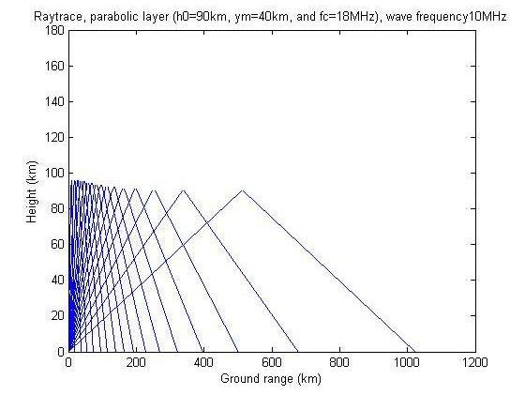

raypath(10, 8, 40, 90)

# C:\Documents and Settings\tony\Desktop\EG7023\2.jpg

For D layer, we can see that when wave frequency is smaller than the critical frequency, there are no penetrating rays. However, when wave frequency is bigger than critical frequency and the ground range is short enough (within skip zone), the rays will penetrate the D layer. Also, we can see that the height of reflection and ray density decrease when the ground range increases in both graphs above.

raypath(10, 8, 40, 105)

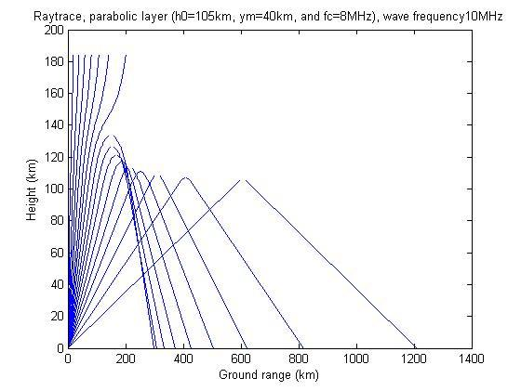

raypath(10, 18, 40, 105)

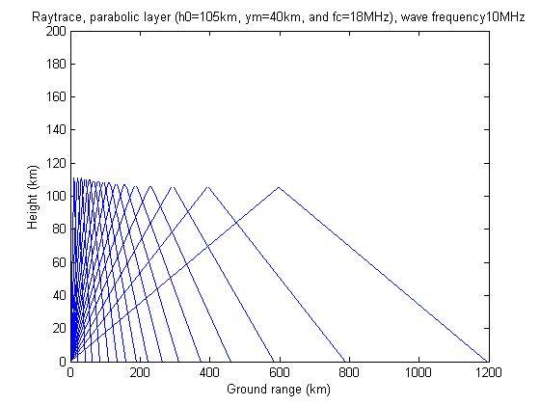

For E layer, the condition is similar as E layer. The difference is that the height of reflection is higher than D layer.

## Running parabolic.m

parabolic(10, 90, 8, 40, 90, 1)

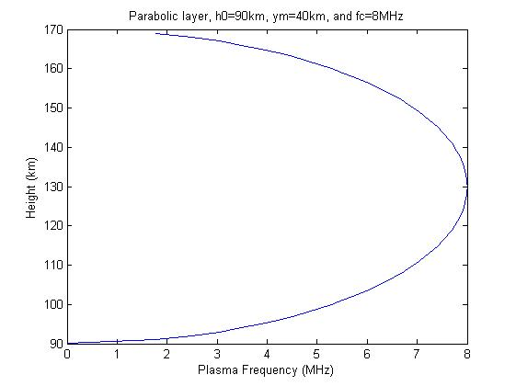

parabolic(10, 90, 8, 40, 105, 1)

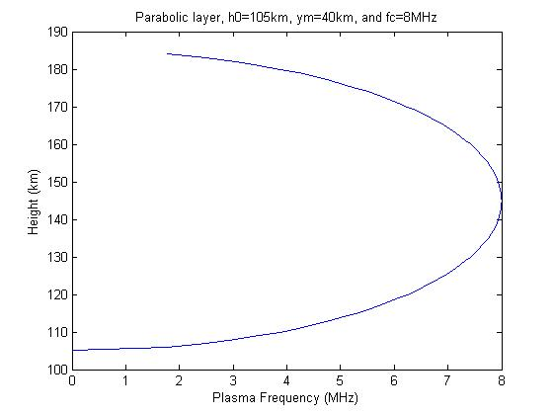

parabolic(10, 90, 18, 40, 105, 1)

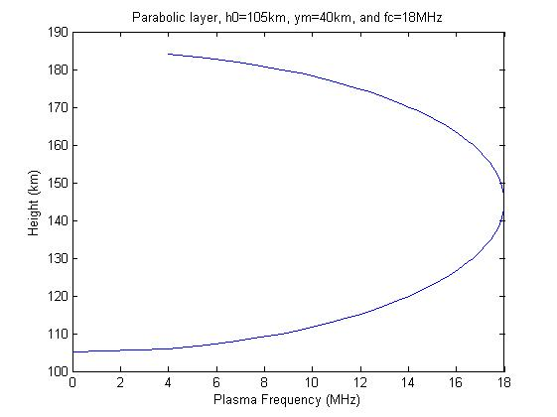

For D and E layers and different critical frequencies, the height of reflection increases when the ray frequency increases.

# Exercise NR1: Investigating the effect of changing elevation angle

Initializing the parameters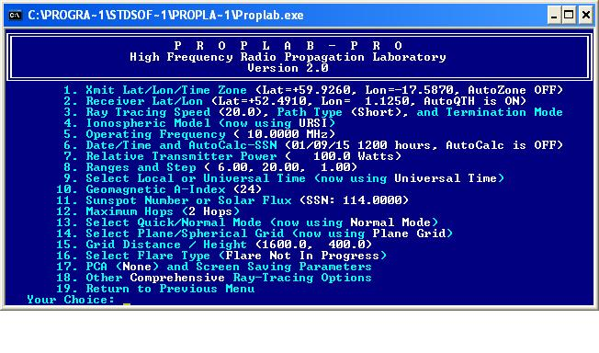

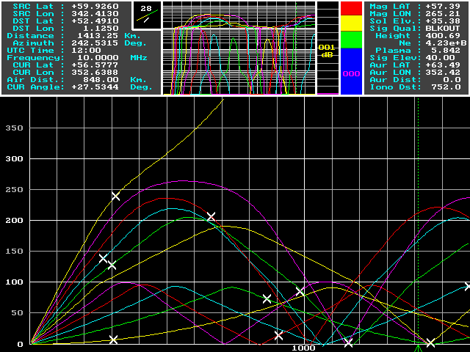

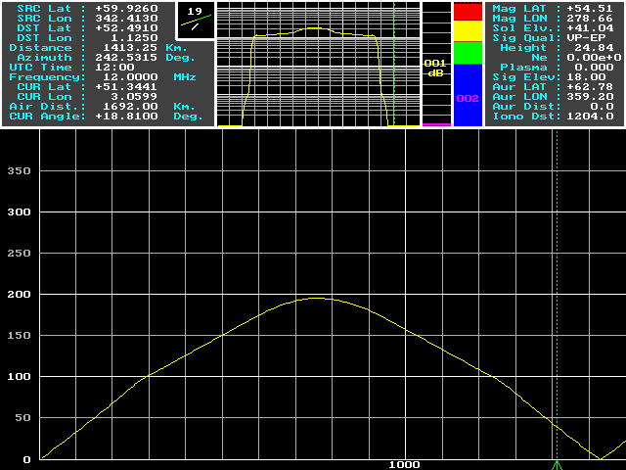

I find that the elevation angle 20° results in a ray landing which is nearest to the receiver.

Also the elevation angles 4° and 16° result in a ray landing near to the receiver.

The signal penetrates the E and F-regions at elevation angle 40°.

# Exercise NR2: Investigating the effect of changing the frequency

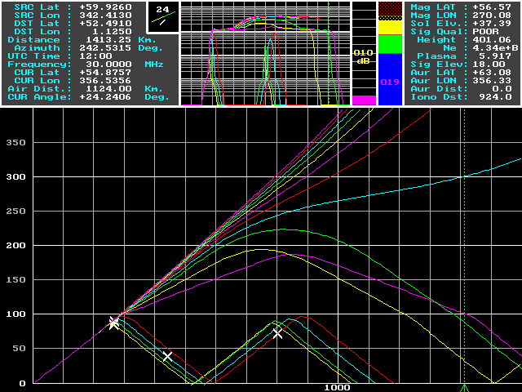

Rays land near to the receiver for the frequency 12MHz (marked as the middle yellow line).

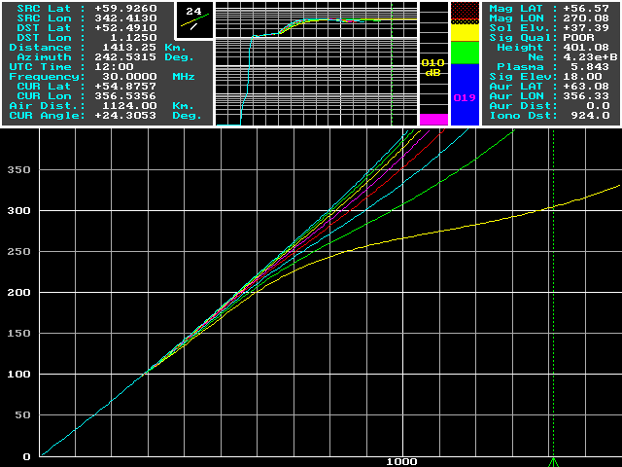

The signal penetrates the E and F-regions at 16MHz (marked as the lower yellow line)

# Exercise NR3: Investigating the influence of the time of day

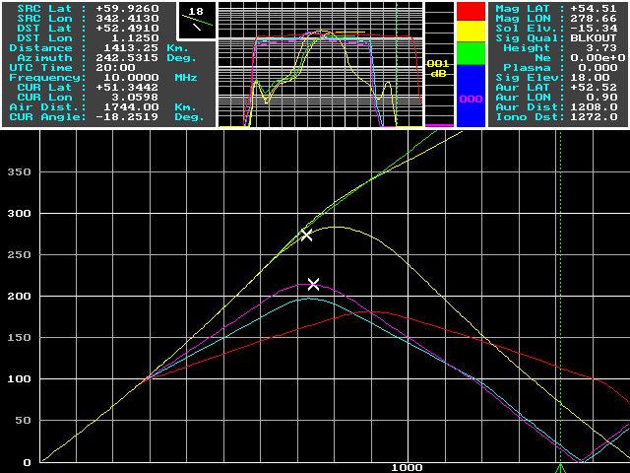

The signal penetrates the E and F-regions at first (0:00am and 4:00am) and then the signal is reflected to the ground (from 8:00am to 8:00pm).

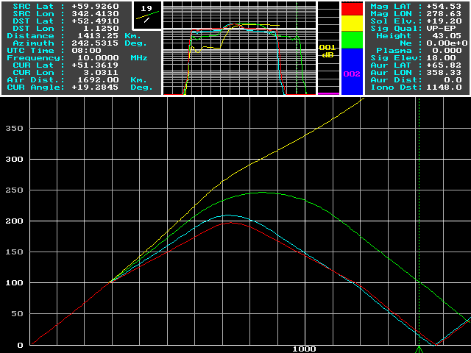

5:00am to 8:00am

We can see that the ray starts to be reflected from 6:00am. (Sunrise)

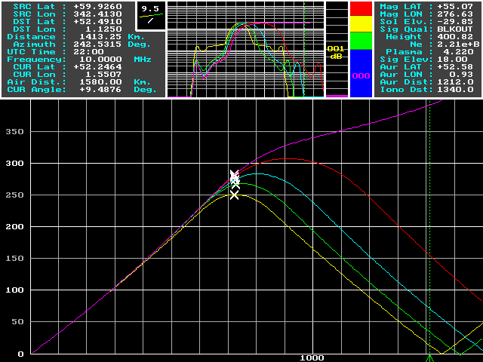

6:00pm to 10:00pm

We can see that the ray penetrates the E and F-regions at 10:00pm. (Sunset)

# Exercise NR4: Explaining the resultsC:\Documents and Settings\tony\Desktop\EG7023\SCREEN7.GIF

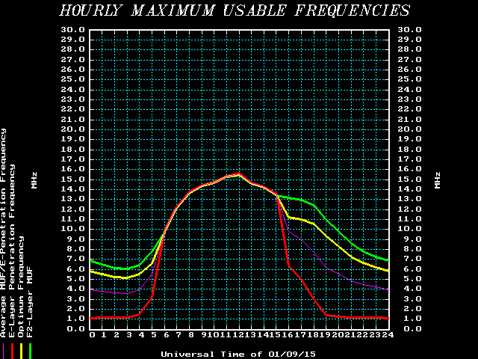

From the graph above, we can see that the penetration frequency is lower in the night time and higher in the day time. Thus, we use same frequency (10MHz) in the previous exercises; the signal penetrates before sunrise or after sunset.